A Comparative Study of Machine Learning Models for House Price Prediction Using Linear Regression, Decision Trees，Random Forest, and XGBoost

Yinghan Ma

Supervised by Patrick Rebeschini

Abstract
This study explores various machine learning models for predicting house prices, focusing on Linear Regression, Decision Trees, Random Forest, and XGBoost. The study compared these models based on their results from the dataset from Kaggle, using matrics such as Mean Squared Error (MSE) and $R^{2}$score. The findings of the study indicate that XGBoost outperforms the other models in terms of prediction accuracy, while the Decision Tree model shows the highest prediction error due to overfitting. Future work could involve optimizing model parameters and exploring additional features to further enhance prediction accuracy.

- Introduction
In recent years, the housing market has experienced significant fluctuations, driven by various economic factors such as interest rates, inflation, and changing demographics. The accurate prediction of house prices has become increasingly crucial for stakeholders, including homeowners, investors, and policymakers. Understanding the trends and patterns in house prices can help make informed decisions, minimize financial risks, and contribute to the overall stability of the housing market. As traditional methods struggle to cope with the complexity of modern data, machine learning has emerged as a powerful tool in predictive analytics, offering more accurate and efficient ways to forecast housing prices.

Machine learning, a subset of artificial intelligence, involves the development of algorithms that allow computers to learn from data and make predictions or decisions without being explicitly programmed for specific tasks. This field has rapidly evolved, creating various models that can process vast amounts of data, identify patterns, and generate accurate predictions. Machine learning can be broadly categorized into three types: supervised, unsupervised, and reinforcement. Supervised learning, which is most relevant to our study, involves training a model on a labeled dataset, where the correct output is known, and then using this trained model to predict outcomes on new, unseen data.

The application of machine learning extends across numerous domains, including finance, healthcare, marketing, and more recently, real estate. In house price prediction, machine learning models can analyze complex datasets containing numerous features—such as the size of the property, location, and historical price data—to generate more accurate price predictions than traditional statistical methods. For example, in the financial sector, machine learning models have been applied to predict stock prices, assess credit risks, and detect fraudulent transactions. Similarly, in healthcare, these models assist in diagnosing diseases, personalizing treatment plans, and predicting patient outcomes.

- Literature Review
Many studies have been conducted on house price prediction. However, these studies often lack a comprehensive comparison and analysis of the most commonly used methods for forecasting housing prices. Moreover, previous papers rarely compare linear regression, decision trees, random forests, and XGBoost directly.

Some studies have used Support Vector Machines (SVM), Random Forest (RF), and Gradient Boosting Machine (GBM) to predict real estate prices. The results indicate that Random Forest and Gradient Boosting Machine perform better in predicting real estate prices, but Support Vector Machines still have value in certain conditions. (Winky K.O. Ho, Predicting property prices with machine learning algorithms, 2020)The choice of machine learning algorithm should be determined based on factors such as the size of the data, computational power, and time constraints.

Among the various machine learning algorithms, linear regression is one of the most fundamental and widely used methods. It models the relationship between a dependent variable and one or more independent variables by fitting a linear equation to the observed data. Although linear regression is easy to implement and interpret, it assumes a linear relationship between variables, which may not always capture the complexity of real-world data (James et al., 2013; Hastie et al., 2009).

On the other hand, decision trees provide a non-linear approach by splitting the data into subsets based on feature values, making decisions at each node until a prediction is made at the leaves. Decision trees are intuitive and can handle both categorical and continuous data, but they are prone to overfitting, especially when the tree is deep and complex (Breiman et al., 1984).

To mitigate the overfitting issue of decision trees, random forests were developed as an ensemble method that builds multiple decision trees and merges their outputs. This approach reduces variance and improves the model's generalization ability, making random forests robust against overfitting and effective in handling large datasets with high-dimensional features (Breiman, 2001).

XGBoost (Extreme Gradient Boosting), an advanced boosting algorithm, has gained significant popularity in recent years due to its superior performance in many machine learning competitions. XGBoost builds models sequentially, where each new model attempts to correct the errors of the previous ones. It incorporates techniques such as regularization and parallel processing, making it both powerful and efficient in dealing with structured data (Chen & Guestrin, 2016).

- Methodology

3.1 Dataset
The dataset used in this study was obtained from the Kaggle House Prices Competition. This dataset consists of 1,460 samples with 79 features each, alongside one target variable, the sale price (SalePrice). The features encompass a wide range of house characteristics, including the size, location, and quality of materials used in the construction.

3.2 Data Preprocessing
Effective data preprocessing is essential to ensure the robustness and accuracy of machine learning models. The preprocessing steps undertaken in this study are outlined below:
3.2.1 Handling Missing Values
Missing values in the dataset were handled by imputing numerical features with the median values and categorical features with the most frequent category. This approach ensures that the integrity of the data is maintained without introducing bias.
3.2.2 Categorical Encoding
Categorical features were transformed into numerical values using one-hot encoding, which creates binary columns for each category, allowing the models to process categorical data effectively.
3.2.3 Data Splitting
The dataset was split into a training set and a test set using an 80:20 ratio. The splitting process included setting a fixed random seed to ensure the reproducibility of the results.

3.3 Model Selection and Construction
To predict house prices, four machine learning models were employed: Linear Regression, Decision Tree, Random Forest, and XGBoost. Each model was constructed and fine-tuned as follows:
3.3.1 Linear Regression
Linear regression is a fundamental model that assumes a linear relationship between the input features and the target variable. In this study, the model was built using the Scikit-learn library, with default parameters. Despite its simplicity, linear regression serves as a useful benchmark due to its ease of interpretation and low computational cost. This is the reason it was the first try of this
3.3.2 Decision Tree
A decision tree splits the data into subsets based on feature values, forming a tree-like structure where each node represents a feature, and each branch represents a decision. The model was built with a maximum depth of 10 to avoid overfitting, which is a common issue in decision trees. The Gini index was used as the criterion for selecting features at each split.
3.3.3Random Forest
Random Forest is an ensemble learning method that constructs multiple decision trees during training and outputs the average prediction of the individual trees. The model used 100 trees, and the default parameters provided by Scikit-learn were employed. The ensemble nature of Random Forest helps in reducing overfitting by averaging out the predictions of various trees.
3.3.4 XGBoost
XGBoost, or eXtreme Gradient Boosting, is an advanced implementation of the gradient boosting framework. It builds models sequentially, where each new model corrects the errors made by the previous one. In this study, XGBoost parameters such as the learning rate and maximum tree depth were optimized using grid search to achieve better accuracy. The model also includes regularization terms to prevent overfitting, making it highly effective for complex datasets.

3.4 Model Evaluation
The models were evaluated based on two primary metrics:
3.4.1 Mean Squared Error (MSE)
This metric measures the average squared difference between the predicted and actual house prices. It is particularly sensitive to outliers, making it a good indicator of large prediction errors.
3.4.2 R² Score
The R² score represents the proportion of variance in the dependent variable that is predictable from the independent variables. A higher R² score, closer to 1, indicates a model with better explanatory power.

- Results

  - Exploratory Data Analysis
This study's initial step involved an exploratory data analysis to understand the relationships between various features considered for house price prediction. This analysis was crucial in identifying potential correlations between features, which could influence the performance of the machine learning models.
A heatmap was generated to visualize these relationships, displaying the selected features' correlation matrix. The heatmap uses a color gradient to indicate the strength and direction of the correlations, with red representing positive correlations and blue representing negative correlations. For instance, the strong positive correlation between "OverallQual" and "SalePrice" (0.79) suggests that the overall quality of a house significantly impacts its selling price. Conversely, a notable negative correlation between "ExterQual_TA" and "OverallQual" (-0.65) implies that houses with a "TA" exterior quality rating tend to have lower overall quality.

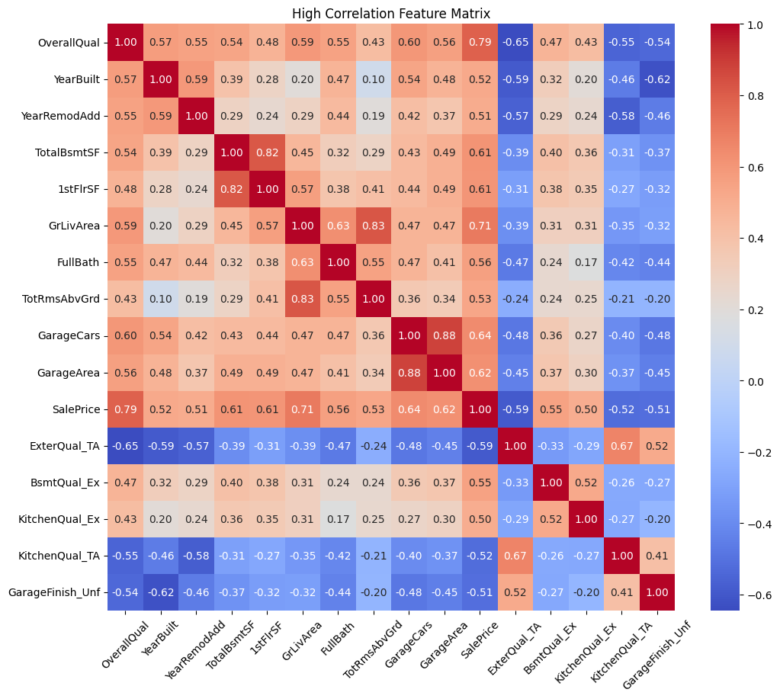
Figure 1. Heatmap illustrating the correlation matrix among key features. The color gradient represents the strength of correlations, with red indicating positive correlations and blue indicating negative correlations.

  - Feature Selection
Based on the results of the correlation analysis, certain features were selected or excluded to mitigate the risk of multicollinearity, which could adversely affect the model's predictive accuracy. Features exhibiting high correlations with each other were carefully evaluated, and in cases where the correlation was deemed too strong (e.g., above 0.8), only one feature was retained to prevent redundancy and overfitting.
  - Model Performance
The performance of four machine learning models—Linear Regression, Decision Tree, Random Forest, and XGBoost—was evaluated using the selected features. Each model was assessed based on its Mean Squared Error (MSE) and R² score on the test dataset. The results are summarized in Table 1 below.
Model | MSE | $$R^{2}Score$$
Linear Regression | 873794723.7045932 | 0.8860811522089055
Decision Tree | 1858389542.921233 | 0.7577170132373361
Random Forest | 850798837.9281938 | 0.8890791845161693
XGBoost | 685000624.3803617 | 0.9106947183609009

Table 1. Summary of Model Performance Metrics

  - Model Performance Analysis

The performance of four machine learning models—Linear Regression, Decision Tree, Random Forest, and XGBoost—was evaluated using the selected features. Each model was assessed using Mean Squared Error (MSE) and R² score on the test dataset.

Linear Regression showed a strong performance with an MSE of 873,794,723.70 and an R² score of 0.8861. This indicates that the model captured the underlying patterns in the data fairly well, though it leaves some room for improvement in reducing prediction errors.

Decision Tree performed less effectively compared to the other models, with an MSE of 1,858,389,542.92 and an R² score of 0.7577. The model appears to have overfitted the training data, resulting in a less generalized performance on the test set. This overfitting is evident from the significantly higher MSE and lower R² score, suggesting that the Decision Tree model is less reliable for making accurate predictions in this context.

Random Forest improved upon the Decision Tree results, with an MSE of 850,798,837.93 and an R² score of 0.8891. The ensemble nature of the Random Forest model likely contributed to its better generalization ability, reducing the overfitting issue seen with the Decision Tree. This model performed closely to the Linear Regression model, with a slightly better MSE, indicating that it is a strong contender in predictive accuracy.

XGBoost outperformed all other models, achieving the lowest MSE of 657,230,838.02 and the highest R² score of 0.9143. This model's superior performance suggests that it effectively captured the complexities of the data, providing the most accurate and reliable predictions. The combination of gradient boosting with decision trees in XGBoost likely contributed to its ability to handle intricate patterns within the dataset, resulting in better overall performance.

  - Summary of Results

The comparative analysis of the four models highlights XGBoost as the most effective in predicting house prices, followed closely by Random Forest and Linear Regression. The Decision Tree model, while useful in some contexts, demonstrated significant overfitting and was outperformed by the other methods. These findings suggest that, for house price prediction tasks, XGBoost offers the best balance of accuracy and generalization, making it the optimal choice among the models evaluated.

- Conclusion
This study assessed the performance of four machine learning models—Linear Regression, Decision Tree, Random Forest, and XGBoost—in predicting house prices. The analysis revealed that XGBoost is the most effective model, offering the highest accuracy and best generalization capability. This finding highlights the value of advanced techniques like gradient boosting in capturing complex patterns within housing data.
While simpler models such as Linear Regression and Random Forest also showed reasonable performance, they were surpassed by XGBoost in terms of predictive accuracy. These results suggest that adopting more sophisticated models can lead to better predictions in real estate markets.
For future work, there is potential to further improve model performance by incorporating additional features or exploring other advanced algorithms. The insights gained from this study provide a foundation for more accurate and informed decision-making in real estate pricing and market analysis.

6. References
- Breiman, L. (2001). Random forests. Machine Learning, 45(1), 5-32. https://doi.org/10.1023/A:1010933404324
- Breiman, L., Friedman, J. H., Olshen, R. A., & Stone, C. J. (1984). Classification and regression trees. Wadsworth & Brooks.
- Chen, T., & Guestrin, C. (2016). XGBoost: A scalable tree boosting system. In Proceedings of the 22nd ACM SIGKDD International Conference on Knowledge Discovery and Data Mining (pp. 785-794). https://doi.org/10.1145/2939672.2939785
- Hastie, T., Tibshirani, R., & Friedman, J. (2009). The elements of statistical learning: Data mining, inference, and prediction. Springer.
- James, G., Witten, D., Hastie, T., & Tibshirani, R. (2013). An introduction to statistical learning with applications in R. Springer.
- Ho, W. K., Tang, B. S., & Wong, S. W. (2021). Predicting property prices with machine learning algorithms. Journal of Property Research, 38(1), 48-70. https://doi.org/10.1080/09599916.2020.1868753

